Rossmoyne Senior High School

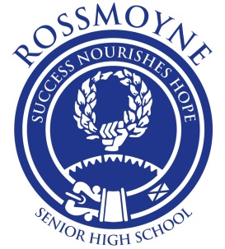

### Semester One Examination, 2015

### Question/Answer Booklet

# MATHEMATICS SPECIALIST

# UNIT 1

## Section Two:

## Calculator-assumed

Your name

Your Teacher’s name

## Time allowed for this section

Reading time before commencing work: ten minutes

Working time for this section: one hundred minutes

## Materials required/recommended for this section

##### *To be provided by the supervisor*

This Question/Answer Booklet

Formula Sheet (retained from Section One)

##### *To be provided by the candidate*

Standard items: pens (blue/black preferred), pencils (including coloured), sharpener,

correction fluid/tape, eraser, ruler, highlighters

Special items: drawing instruments, templates, notes on two unfolded sheets of A4 paper, and up to three calculators approved for use in the WACE examinations

## Important note to candidates

No other items may be taken into the examination room. It is **your** responsibility to ensure that you do not have any unauthorised notes or other items of a non-personal nature in the examination room. If you have any unauthorised material with you, hand it to the supervisor **before** reading any further.

## Structure of this paper

|  |  |  |  |  |  |
| --- | --- | --- | --- | --- | --- |
| Section | Number of questions available | Number of questions to be answered | Working time (minutes) | Marks available | Percentage of exam |
| Section One:  Calculator-free | 7 | 7 | 50 | 52 | 35 |
| Section Two:  Calculator-assumed | 13 | 13 | 100 | 98 | 65 |
|  | | | **Total** | 150 | 100 |

## Instructions to candidates

1. The rules for the conduct of Western Australian external examinations are detailed in the *Year 12 Information Handbook 2015*. Sitting this examination implies that you agree to abide by these rules.
2. Write your answers in this Question/Answer Booklet.
3. You must be careful to confine your response to the specific question asked and to follow any instructions that are specified to a particular question.
4. Spare pages are included at the end of this booklet. They can be used for planning your responses and/or as additional space if required to continue an answer.

* Planning: If you use the spare pages for planning, indicate this clearly at the top of the page.
* Continuing an answer: If you need to use the space to continue an answer, indicate in the original answer space where the answer is continued, i.e. give the page number. Fill in the number of the question that you are continuing to answer at the top of the page.

1. **Show all your working clearly**. Your working should be in sufficient detail to allow your answers to be checked readily and for marks to be awarded for reasoning. Incorrect answers given without supporting reasoning cannot be allocated any marks. For any question or part question worth more than two marks, valid working or justification is required to receive full marks. If you repeat any question, ensure that you cancel the answer you do not wish to have marked.
2. It is recommended that you **do not use pencil**, except in diagrams.
3. The Formula Sheet is **not** to be handed in with your Question/Answer Booklet.

Section Two: Calculator-assumed (98 Marks)

This section has**thirteen (****13)** questions. Answer **all** questions. Write your answers in the spaces provided.

Working time for this section is 100 minutes.

Question 8 (5 marks)

Three vectors are given by ,  and .

(a) Use your calculator to determine the angle between , to the nearest degree.

(2 marks)

(b) Determine all possible values of  if  and  are perpendicular. (3 marks)

Question 9 (8 marks)

(a) A multiple choice test has twelve questions and each question has three possible choices. If all questions are attempted, in how many ways can the test be answered? (2 marks)

(b) A set S contains all the integers between 3 and 102 inclusive. Determine

(i) how many numbers in set S are multiples of 7. (1 mark)

(ii) how many numbers in set S are multiples of 3 or 7. (2 marks)

(iii) how many numbers in set S are multiples of either 3 or 7 but not both. (1 mark)

(c) Ten points are equally spaced around the circumference of a circle. Determine the number of simple (non-self-intersecting) convex polygons that can be formed by joining either three, four or five of these points with straight line segments. (2 marks)

Question 10 (8 marks)

Three forces are applied to a body. One has magnitude 300 N and acts due south. Another has magnitude 250 N and acts on a bearing of 050º.

(a) If all three forces are in equilibrium, determine the magnitude and direction of the third force.(Hint: third force of magnitude T acting at  to vertical which balances the other two) (4 marks)

(b) If the third force has a magnitude of 350 N and acts on a bearing of 250º, determine the magnitude and direction of the resultant force. (4 marks)

Question 11 (6 marks)

(a) A triangle  has vertices ,  and . Determine the vector , where  is the midpoint of side . (3 marks)

(b)  is a triangle with point  on side  such that . If  and , show that . (3 marks)

Question 12 (6 marks)

(a) Vectors  have the same magnitude and vectors  are perpendicular, where  ,  and  Determine the values of  and . (3 marks)

(b) Determine the scalar projection of a velocity of 12 m/s on a bearing of 65º onto a velocity of 20 m/s on a bearing of 280º, giving your answer to three significant figures. (3 marks)

(

)

Question 13 (8 marks)

(a) A triangle has vertices at ,  and .

(i) Determine the vectors . (2 marks)

(ii) Use a vector method to prove that triangle  is right-angled. (2 marks)

(b) Use a vector method to prove that if the diagonals of a parallelogram are perpendicular to each other, then the parallelogram is a rhombus. (4 marks)

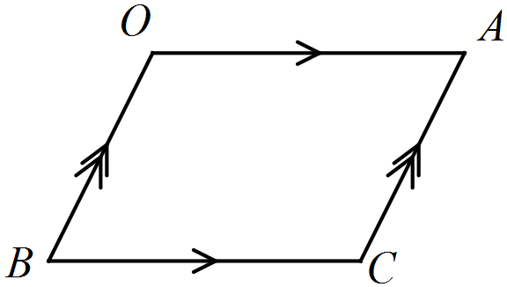

Question 14 (8 marks)

(a) Two circles of radius 12.6 cm, with centres  as shown below, have a common chord . Determine, with justification, the length . (3 marks)

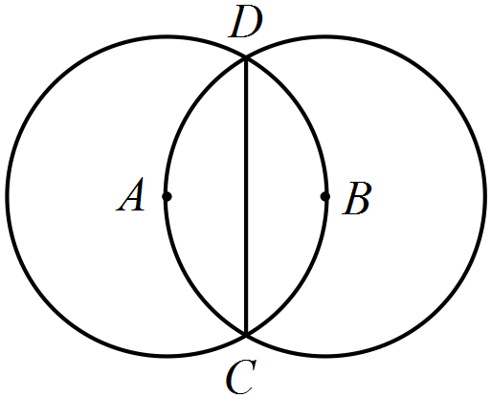

(b) In the diagram below, . Determine, with **justification**, the exact length of . (5 marks)

(Hint: consider the triangles  and  )

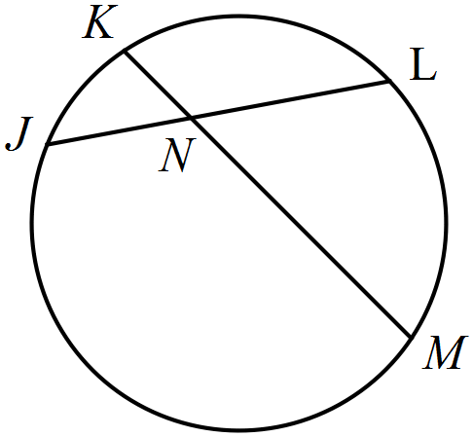

Question 15 (9 marks)

(a) A small body A has position (12, -3) m relative to another small body B. If a third small body C has position (-5, 6) relative to A, determine the position of B relative to C.

(2 marks)

(b) To a cyclist moving with velocity (21, -5) km/h the wind appears to have velocity (-9, 3) km/h. Determine the true speed of the wind. (3 marks)

(c) A small ship is travelling with a constant speed of 14 knots on a bearing of 025º and another, larger ship is travelling with a constant speed of 17 knots on a bearing of 310º.

Determine the velocity of the large ship relative to the small ship. (4 marks)

Question 16 (9 marks)

The medians of triangle  are , as shown below.

(A median joins a vertex to the midpoint of the opposite side of the triangle).

Let .

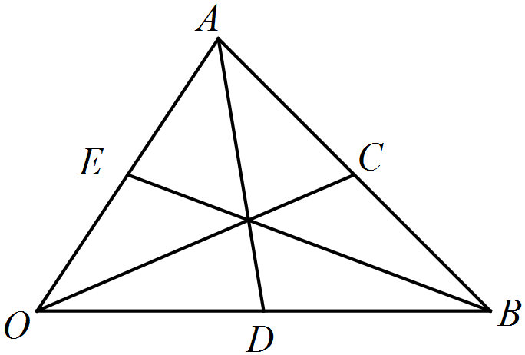

(a) Prove that . (4 marks)

(b) The centroid, , is the point of intersection of the medians.

Determine  in terms of . (5 marks)

(*Hint: Let , and first solve for  and by considering *)

Question 17 (8 marks)

(a) The diagram shows a triangle with vertices  that lie on a circle with centre . Chord  passes through . Prove, by contradiction, that angle  is acute.

(4 marks)

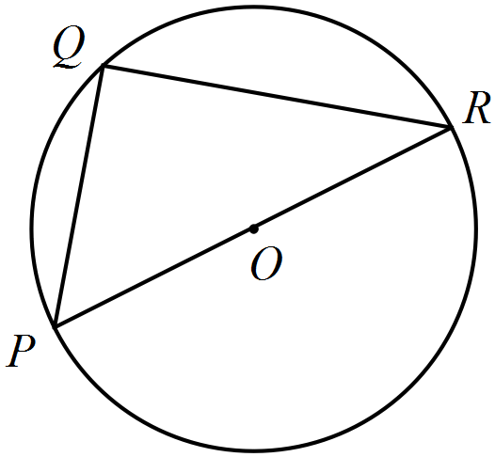

(b) In the diagram below,  is the centre of the circle on which points  lie. Chord  passes through and  is parallel to . Prove that the quadrilateral  is a rectangle. (4 marks)

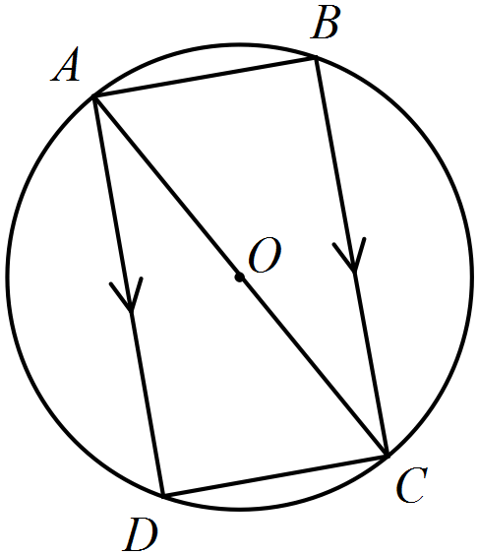

Question 18 (10 marks)

(a) A small coach has 24 seats, arranged in six rows of four seats each, with two seats in each row on either side of the central aisle. A group passengers consisting of ten males and nine females board the bus.

(i) Determine how many combinations of empty seats are possible once everyone has sat down.(Hint: consider the number of empty seats out of 24) (2 mark)

(ii) How many fewer combinations are there if the females all sit on one side of the aisle and the males all sit on the other side? (3 marks)

(Hint: Consider the number of empty seats in each group of 12 seats)

(b) Determine the number of possible four letter permutations of the letters of the word

(i) RELOAD. (2 mark)

(ii) RELOADED. (3 marks)

Question 19 (9 marks)

A small boat has to travel across a river from  to , where  and metres. A uniform current of  m/s is flowing in the river and the boat can maintain a steady speed of 4 m/s.

(a) Determine, in the form , m/s, the velocity vector the small boat should set to travel directly from  to . (6 marks)

(b) Calculate, to the nearest minute and second, how long the journey will take. (3 marks)

Question 20 (4 marks)

(a) In the diagram below,  is a tangent to the circle at . If ,  and , determine the size of angle . (4 marks)

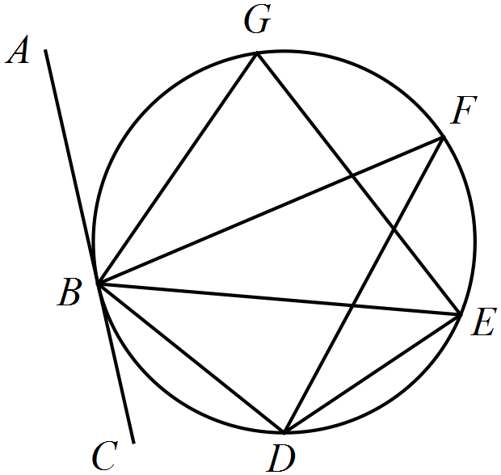

Additional working space

Question number: _________

This examination paper may be freely copied, or communicated on an intranet, for non-commercial purposes within educational institutes that have purchased the paper from WA Examination Papers provided that WA Examination Papers is acknowledged as the copyright owner. Teachers within Rossmoyne Senior High School may change the paper provided that WA Examination Paper's moral rights are not infringed.

Copying or communication for any other purposes can only be done within the terms of the Copyright Act or with prior written permission of WA Examination papers.

*Published by WA Examination Papers*

*PO Box 445 Claremont WA 6910*